Perspective Building for CLF Leadership on Gender (as part of CLF Visioning Process)

Objective of the training:
At the end of the training the participants (EC members of the CLF) shall go back with:
- Basic understanding about intersectional forms of gender discrimination faced by women through their life cycle based on their lived realities
- Understanding of factors leading to these issues, nature of these factors, strategies to work on these issues, stakeholders related to the issues identified, skills and capabilities required for bringing about change

Methodologies:
- Knowledge inputs - lecture and presentations
- Group and plenary discussions
- Planning sessions
Session-time | Session plan | Method/tools | Materials required
5 minutes  10 minutes  15 minutes | Welcome address and brief sharing about the meeting by CLF President  Introductions (required if the facilitator for the module is meeting participants for the first time; skip if resource person is already in touch with the group)  Sharing of Session Objective | CLF President welcomes Resource Person and Members for the half-day session  Sharing of names and roles by participants and resource person  CLF President / any other OB member (preferably OB members or any other EC member, not a cadre) shares the objective of the meeting, giving details of the visioning process, including the VO level visioning exercises, consolidation of issues and overall priorities that have emerged, including the ones that are related to ‘gender’ issues, and shares that the half-day session is required for a perspective building and inputs from the resource person on gender issues and how CLF may work on the same.  OR  Resource Person may give the above background and then request CLF to share the priorities that have emerged from consolidation exercise | No materials needed  No materials needed  Chart papers / presentation on visioning process, and priorities that have emerged along with number of VOs that articulated those priorities (this may be prepared beforehand, taking support from relevant cadres supporting the CLF in this process)
2 hours | - Concepts on gender equality: (gender division of labour, women and work, violence against women, women and leadership, women’s voice in decision making, women’s access to assets/property (60 mts.)  - Group presentation (30 mts.)  - Tie up key concepts (30 mts.) | Exercise 1:  Sociogram :  Sociogramming means ‘social mapping’. In this exercise, questions will be asked, or statements made to get a picture of the participants in any domain of life—education, mobility, marriage, community, violence, etc.  - These questions tell us about the process of socialisation and the status of women in terms of how the participants actually live through the gender identities assigned to them.  - The participants will stand in a circle. The facilitator will make a statement and ask those who possess/have/agree to the statement come to one side. Those who do not possess/have/ disagree to go to another side. The reasons for agreement and disagreement can be explained and jotted down on board. Not all statements should be taken. One can pick a few.  Questions for discussion (any 7 questions):  - Those who are married  - Those who are literate/10th pass/12+  - Those who can travel alone at any time  - Those who need not take permission but merely inform their families when going out  - Those who have no restrictions within the family to participate in any ritual  - Those who have no restrictions to move in any place of the village  - Those who have no restrictions to move in any place within the family  - Those who can use bicycles or motorcycles to commute  - Those who have encouraged their daughter to use a bicycle  - Those who can go to the panchayat, block and market for different reasons  - Those who have bank accounts  - Those who have jobs  - Those who have income  - Those who have freedom to use earnings  - Those who have gadgets in the house to support domestic work  - Those who have assets in joint ownership  - Those who have assets in own name  - Those who believe that education for women will improve their status  - Those who think that assets in women’s name will improve their status  Points to facilitate discussion:  - This exercise helps one understand different barriers faced in day-to-day functioning, and these barriers are often due to the process of socialisation.  - Gender roles, norms and relations are taught through socialisation. Socialisation is a process of informal education which imparts certain values, attitudes and behavioural codes to individuals. These behavioural codes are different for men and women. They often put greater restrictions on the freedom of choice, expression and movement for women in comparison to men in most societies.  - Socialisation is a continuous process. Several institutions, starting with the family into which a child is born, help in the process of socialisation. The sources from which we learn gender-based behaviours are family, friends, tribe, peer groups, society, religion, culture, traditions, schools, customs, proverbs, media, legal provisions, etc.  Or,  - Exercise2: 4 Small group discussions: give each group one concept to discuss and identify gender gaps, critical issues  - Summarize group discussions  - Ppt 1: Posters on Gender Equality: Pictorial ppt (2 posters attached along with a separate PPT in PDF form)  - Film 1: if possible – What is Gender – by Jagori http://www.dalitweb.org/?p=1578 | Charts, pens,  Posters on equity and equality  Gender based discriminations, caste and class-posters  Lecture.
15 minutes  45 minutes  45 minutes  30 minutes | Session will focus on:  Locating Women’s Position and Condition in the State  Identification of Hindering and facilitating factors for priorities identified by the CLF  How can federation work on these issues, reduce hinderances and increase facilitators?  Wrap-up session  Developing vision statement, objectives | NFHS -5- State data  The NFHS -5 State data on gender indicators can be presented. This can be done as an input session. They can be asked if they think this is true in their respective areas and what are the reasons. The indicators with respect to sex ratio, access to drinking water, fuel, anaemia during adolescence, pregnancy, violence, decision making, etc can be reflected upon.  Resource person will share a presentation giving data on sex ratio, child sex ratio, age at marriage, literacy percentage, girls out of school, MMR, reproductive health, crime against women, other local forms of GBV such as witch hunting, trafficking  Take 1 or 2 priorities as examples for discussion on hindering and facilitating factors for the specific issue. The exercise may be done in plenary on chart paper. (for example, a facilitating factor for violence may be that it is accepted and part of the culture, a hindering factor is that police stations are located far away and not responsive). A classification of the hindering and facilitating factors into internal and external may also be done (for example, the fact that violence is accepted is internal factor to community, and the fact that police station is situated far away and not responsive is an external factor). This exercise will also lead to identification of critical actors who are or may need (for example, jati panchayat, women, SHG, VO, mukhiya or traditional village head, police station) to be involved in the issue.  Taking one of the examples, continue the discussion to identify what CLF can do on its own and for what it will need support from outside (for example, to work on culture and acceptance in the community, CLF can work on its own, but for improving responsiveness of police station, it may require support from outside). Building on this, what knowledge and skill it already has and what is required to be acquired may also be discussed (for example, CLF knows who are the influential people in the community and VOs can take the lead in initiating dialogue with them, but CLF may need training on legal provisions on domestic violence).  The objectives of gender integration aligned to the vision statement can be developed. The action plan can be developed. In alignment with vision and sociogram which reflects their status, CLF can develop one year action plan.  The responsible person for documentation from the CLF then then reads out a summary of the deliberations that happened during the day. CLF EC members add to the points or suggest any modifications to be made. They instruct the person to make a final document for further discussion in the AAP exercise to be conducted after agreed upon interval. Dates for the same are communicated to all CLF EC members. CLF President thanks the resource person for his or her time. | A designated person from the CLF good in taking down minutes should be identified beforehand and she should meticulously record all the discussions taking place including summarization and finalization of various points.

Appendix:
Exercise 2:
Objective: Analyse gender issues
Time: (60 mts.)
Step 1: Form 5 Small groups: Give each group one concept to discuss and ask them to identify gender gaps and critical issues within them
- Gender division of labour
- Women and work
- Ending Violence against women
- Women’s voice, leadership and decision making
- Women’s access to assets/property/land rights

Step 2: Give each group the following questions to address:
- What are 2-3 key issues you can identify with regard to this theme?
- How does it affect diverse women? Are all women’s experiences the same?
- How do they respond to these gender gaps?
- What support do women need to change this situation?

Step 3: Large group session
- Each group presents their points
- Discuss each issue and summarise

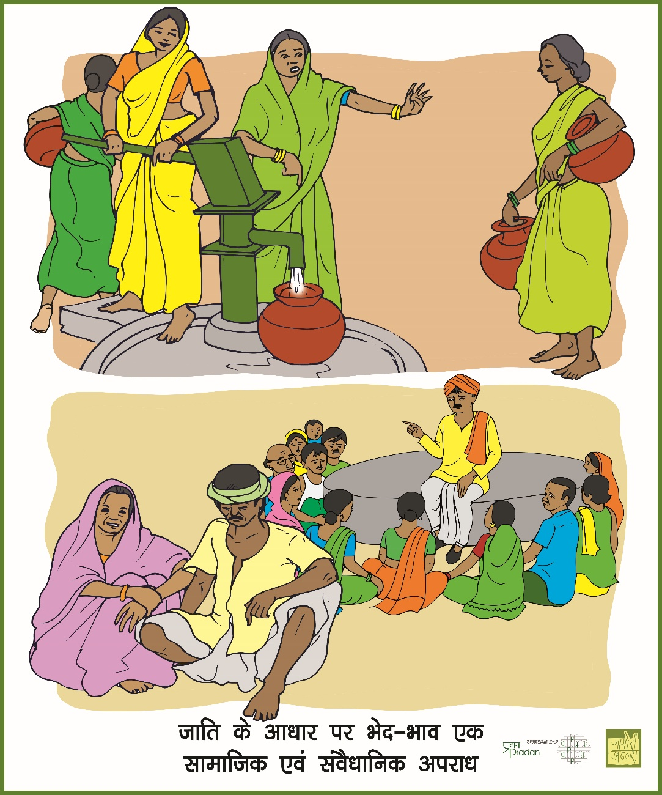

module for Half day Training after visioning exercise & before AAP Preparation

Recap of session done during visioning module 3 training.

Time- Thirty minutes

Institutional mechanisms- GPP, VO SAC, CLF SAC, Gender Forum
The facilitator will draw the following structure to help participants understand the institutional mechanisms within DAY–NRLM.
The facilitator will divide the participants into two groups:

Group 1 will discuss:
      - Who will be the GPP?
      - What are the roles and responsibilities of the GPP?
      - How will the GPP intervene in an issue at the SHG level?
      - What are the support systems to address the issues?

Group 2 will discuss:
      - What is the Sakhi Manch?
      - Who are the members of the Sakhi Manch?
      - How will it function?

The groups will make presentations. The facilitator will consolidate the points and explain the role of the GPP and her selection from the SHG. The SHG can be oriented on the selection of the GPP by the VO SAC. After the VO SAC is trained by the Community Resource Person, they can train the SHG on selection of the GPP keeping in mind the essential prerequisites.
The composition, role and responsibilities of the Sakhi Manch (gender collective) will be explained. She will explain how two to three members of the Sakhi Manch can also serve as ex-officio members of the social action committee and look into social issues. The Sakhi Manch is a solidarity forum which is a consolidation of GPPs at the village level.
The facilitator will explain the support system to address different issues, such as toll free numbers, gender forum, Social Action Committee, children’s helpline, women’s helpline, women protection officers, one stop crisis centre, integrated child development officer, police station, etc.
Points for discussion:
- Institutional mechanisms like the GPP and Sakhi Manch would be instituted to take up the social development agenda
- The constitution, roles and responsibilities of the GPP and Sakhi Manch

Session 2:

Exercise 2: The facilitator will divide the participants into two groups and ask them to perform role plays on the functioning of the VO SAC and the CLF SAC. The first group will depict how the VO SAC would deal with practical gender issues, and the second group will show how the CLF SAC can deal with strategic gender needs. Practical gender issues of priority can be taken up, agenda fixed, discussions undertaken, strategy and action points finalized, minutes written, and intervention recorded in the register. The second group can similarly depict the CLF SAC selecting strategic gender needs of priority, fixing the agenda, discussing strategy, activity and intervention, writing minutes and maintaining the register.

Roles and responsibilities of the VO SAC
Consolidating comments on the role play, the facilitator can explain the composition, role and responsibilities of the social action committee, and how two to three members of the sakhi manch can serve as ex-officio members of the social action committee and look into these issues. The social action committee can take up different issues such as retention of children in school, child marriage, domestic violence, asset creation in women’s name, human trafficking, etc., with respective departments for redressal and convergence to ensure attainment of rights and entitlements.
Members of the social action committee also need to be trained on the preventive legal mechanisms, legal provisions and the various services, schemes and institutions for convergence. The need for gender sensitization and training at all levels can be explained.
The social action committee focuses on social inclusion, gender, vulnerability reduction, social security, social development and convergence in the village. It offers special support to SHGs of People with Disabilities, the elderly and other vulnerable groups, and their solidarity federations. It works with children, adolescent girls, women, PwDs, elderly and other vulnerable groups to meet their special needs. It also facilitates vulnerability reduction planning and gender responsive convergence planning and their roll-out, works with the gram panchayat, MGNREGA, social security schemes and other departments.
The facilitator will also explain the composition, role and responsibilities of the social action committees at the CLF level. The CLF SAC can take up practical gender needs and strategic gender needs. The CLF SAC can work with block level officials like the BDO, CDPO, ICDS supervisor, police department and education officer on higher order issues or issues which have escalated from the VO level. The method of conducting meetings, documents like the agenda, minutes and register will be explained. The issues explained earlier can be reiterated.
Gender forum (panchayat level)
The facilitator will further discuss the composition, role and responsibilities of the gender forum.
The gender forum at the panchayat level comprises the VO SAC, elected representatives, anganwadi workers, ASHA, police beat and school principal. The gender forum will be chaired by the VO SAC and the gender issues from the level of the SHGs will be taken to the gender forum. The gender forum can be oriented on basic gender concepts, gender discrimination, gender issues and institutional mechanisms for gender integration, and the role of the gender forum in taking action and resolving issues. Practical and strategic gender needs can be addressed by the gender forum.

Gender forum (block level)
The facilitator will further discuss the composition, role and responsibilities of the gender forum.
The gender forum at the block level comprises the CLF SAC, elected representatives of the block panchayat, BDO, education officials, police department, revenue department, etc. The gender forum will be chaired by the SAC. The gender forum can be oriented on basic gender concepts, gender discrimination, gender issues and institutional mechanisms for gender integration, and the role of the gender forum in taking action and resolving issues. Practical and strategic gender needs can be addressed by the gender forum, and issues can be escalated from the panchayat level gender forum to the block level.
Gender justice centre (block level)
The facilitator will discuss the composition, role and responsibilities of the gender justice centre.
The gender justice centre is a virtual and physical space at the block level to deal with practical and strategic gender needs. The gender justice centre is managed by a cluster level federation in order to enable women to access their rights. The model CLF or any other CLF can manage in rotation. The issues can be dealt with the support of block level officials. The issues at the gender justice centre range from dealing with accessing entitlements to violation of rights.

Questions for discussion:

- What is the role of the GPP in the SHG?
- What is the composition, role and responsibility of the social action committee in the VO and CLF?
- What is the composition, role and responsibility of the gender forum at the panchayat and block levels?
- What is the role and responsibility of the gender justice centre?

Points to remember:
- The institutional mechanisms developed for intervention and action in the field are the GPP at the SHG level, the social action committee at the village organization and cluster federation level, the gender forum at the panchayat and block levels, and the gender justice centre at the block level.
- The GPP is an SHG member, socially sensitive, and will take on the responsibility of training SHGs, putting gender on the agenda in SHG meetings, taking a gender pledge, and undertaking action and intervention on gender issues.
- The VO SAC will comprise two to three members from the VO Executive Committee and will look after social development issues. The agenda for social development will be ensured in the VO every month. They will discuss, intervene and initiate action on social development issues. They will work with village level institutions like elected representatives, Anganwadi workers, ASHA, police beat, Auxiliary Nurse Midwife, school principal, etc. They need to maintain documents like the agenda, register and minutes.
- The CLF SAC will comprise two to three members from the CLF EC and will look after social development issues. The agenda of social development will be ensured in the CLF each month. They will discuss, intervene and initiate action on social development issues at the block level. They can work with block level institutions like the BDO, education officer, ICDS supervisor, health officer, police officer, etc. They need to maintain documents like the agenda, register and minutes.
- The gender forum at the panchayat level comprises elected representatives, Anganwadi workers, ASHA, police beat, ANM, school principal and VO SAC. The VO SAC will chair the session and take up practical and strategic gender needs ranging from water, food and nutrition, job card, ID card to access to assets and resources like land, house, equipment, etc., retention of children in school, prevention of child marriage, etc.
- The gender forum at the block level comprises the BDO, education officer, ICDS supervisor, health officer, police officer and the CLF SAC. The CLF SAC will chair the meeting and take up practical and strategic gender needs at the block level. The issues escalated from the VO SAC can be taken up.
- The gender justice centre is a virtual and physical space at the block level managed by a cluster level federation to look into access to entitlements and rights. The gender justice centre will be managed by the CLF on a rotational basis and the CRPs trained on gender issues would provide continuous support at the field level in resolving issues. Issues related to violation of rights and violence against women will be taken up. Registers will be maintained and documentation of all cases and interventions will be undertaken. Capacity building and knowledge dissemination will be undertaken on acts and laws.

Gender integration in NRLM
Exercise 5
Time: 30 minutes

Gender Integration in Institution Building, Social Inclusion, Livelihoods and Financial inclusion will be explained through the support of PPT. It will be input session with feedback.

Hand- out



