Visioning Module: Planning with Resource Organizations

Food Nutrition Health and WASH (FNHW)

Session | Topic covered | Duration (mins)
1 | Introduction and Overview | 15
2 | - Linkages of FNHW and Livelihoods  - Understanding the CLF Vision  - Roles and Responsibilities | 60
3 | Tools to facilitate Action Planning  - Micro Plan  - Triggering  - Integrating Gender | 35
4 | Social and Behavior Change communication (SBCC) | 30
5 | Review and Monitoring | 40
6 | Preparation and consolidation of Action Plan | 60

Session 1: Introduction and Overview

Objective of the training:
At the end of the training the participants (EC members of the CLF) shall go back with:
- Enhanced understanding of the linkages and need for integration of FNHW with Livelihoods
- Enhanced understanding on what needs to be done for improved and sustained FNHW practices among SHG households
- Enhanced understanding on what is to be done for improved access to and utilization of FNHW services and programs by SHG households
- Understanding on the steps to develop action plan for identified FNHW issues

Preparations before the training:
- The Resource persons / Facilitators should be aware of the contents of the state operational strategy and the proposed implementation structure and the resources to be used for proposed implementation of the strategies.
- The Resource persons / Facilitators should be able to comprehend the local context, the socio –economic dynamics, be aware of the Module 1 and 2 and the prioritized FNHW issues of the specific area.
- FNHW vision of the CLF should be specifically articulated and the vision clearly drawn on a chart paper beforehand for discussion.
- Materials required for the exercises and discussion such as flip charts, chart papers, markers, pens, etc. to develop the action plan should be kept ready.
- The Resource persons / Facilitator should know about the outputs and outcomes expected from this exercise.

Session 2
a: Introduction to FNHW and its linkages with livelihoods
Session Objective:
Understanding on why FNHW and its links with livelihoods.
Session Details:
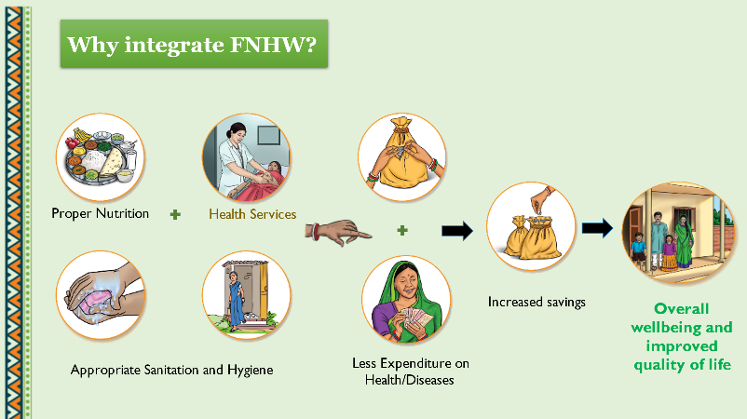
- Discuss with the participants that livelihoods, good health, good nutrition and proper sanitation are inter- dependent.
- Inform that a healthy person is able to better engage in livelihood activities and be economically productive to her/his full potential.
- Health care expenditure leads to depleted household savings, loans and greater household distress and poverty.
- Women and children are the worst affected if FNHW component is not integrated, since they are more vulnerable and susceptible to illnesses. Elderly in the family is also affected more if good nutrition and proper health care is compromised.
- Give examples with the help of this illustration.

Session 2
b: Understanding the CLF Vision
Session Objective:
- Understanding CLF’s Vision and prioritization specific to FNHW issues
- The Resource persons / facilitator shall get an understanding of what all has been discussed in the previous iterations of Module 1 and 2 on issues regarding Food, Nutrition, Health and WASH.
Session Details:
The session would focus on sharing of the identified FNHW issues and decisions taken by the CLF.
- Invite the CLF president to share what they have finalized as their priorities and issues under FNHW.
- As mentioned earlier it would be helpful to prepare charts clearly mentioning the CLF vision, prioritized FNHW issues etc.
- Prepare this sheet before the meeting so that the leaders can articulate accurately.
- Request the CLF President to discuss about existing opportunities and resources within the SHG network and the additional resources and support required, in order to tackle identified issues.
- The identification of the available resources and additional resource required will be detailed out during the planning activity also.
- The steps involved in entire thematic visioning and planning exercise are as below. Step 1 and 2 have been completed till now.

c. Roles and responsibilities
- SHG / VO / CLF level / Cadres / Block / District / State
The CLF will be responsible for undertaking the strategizing and planning process. However, facilitation support needs to be provided by the staff. The roles and responsibilities at different levels are given below.
- The state staff will identify and train resource persons to facilitate the Visioning 3 training with all the Model CLFs in the state.
- The module and tools for imparting this training will be shared with the resource persons by the staff. An orientation on FNHW state operational strategy shall also be given to the identified resource persons.
- District and Block level staff will ensure that the CLF visioning exercise plan for the Model CLF’s is prepared and timely executed.
- District and Block staff will also ensure that all preparatory work for CLF visioning exercise is done in a timely manner including logistics and material support.
- Resource Persons shall support CLF in strategizing and developing action plan for addressing the identified issues through participatory methodology.
- Once the visioning exercise is done, the CLF members need to ensure that all members are aware of the action plan and roles and responsibilities are assigned.
- CLF will include discussion on identified FNHW issues in the agenda of the meeting, maintain record in the minutes and Action Taken Reports.
- CLF members shall review implementation of the developed plan along with the other issues, and undertake frequent monitoring visits to provide supportive supervision to the VOs
- CLF members will establish convergence with the line departments, coordination with thematic cadre (Pashu Sakhi, Krishi Sakhi, CRP-EP etc) within the SHG network, discuss the issues and support required from the field functionaries of line departments.
- CLF and VO members will present community issues in convergence forums like Gram Sabha, Village Health Sanitation and Nutrition Committees, Convergence meetings with the line departments etc, as appropriate.
- VO members will ensure that the issues identified in their VO are prioritized in the action plan. They will also be responsible for convergence with frontline workers of other line departments and other verticals for FNHW related issues.
- VOs will also collate SHG level reports of interventions and report to the CLF.
- The SHG members through their monthly meetings on FNHW and other interactions will take up the role of awareness generation, imparting messages and other peer activities. The minutes will be recorded, and Action Taken Report shall be maintained.
- The District and Block staff may facilitate and provide support to CLF and VO to engage with relevant departments in realizing the FNHW entitlements by SHG members. And report on the progress regularly.

The facilitator should refer to the detailed roles of different levels as given in the activity matrix in Annexure 1 of this document.

Session 3: Tools to facilitate action planning
This session elaborates on the tools required for developing an action plan. These tools will facilitate identification of micro level issues, its causes and probable solutions. There are some associated activities with the tools that are annexed to this document and can be referred only if time permits.
It is suggested that a separate orientation on FNHW planning at CLF level should be organized where these activities should be undertaken.

- Many behavioral and service-related issues on FNHW may be prioritized by the CLF for action and an appropriate plan with roles and responsibilities of the key stakeholders shall be developed
- These issues will vary in the way action is needed; the issues could be - low ANC coverage, high prevalence of maternal mortality, neo-natal morbidity and mortality, poor diet diversity, prevalence of open defecation, irregular functioning of Anganwadi centres, health services supply side issues, and others like access to services and entitlements at the community levels etc.
- For each of these issues, it is important to discuss a little deeper and understand the causes (immediate, intermediate and long term) and probe for possible solutions.
- Initiate this discussion with the group with the help of simple tools.
- We will discuss two tools here – micro planning and Triggering. Activities to enable integration of gender aspects will also be discussed in this section.

- Tool 1 - Integrated FNHW Microplanning for each of the issues identified
- To generate awareness on need for improved behaviours around food, nutrition, health and WASH among the family including women, girls and children
- To enhance their decision-making capacity on health and nutrition issues.
- To build their skills and augment knowledge levels in identifying issues and addressing the issues related to FNHW
For the Facilitator
- Micro-planning is a comprehensive planning approach where in the community prepares development plans themselves considering the priority issues and needs.
- Inclusion and participation of all sections of the community is central to micro-planning, thus making it an integral component of decentralized governance.
- For any development to be sustainable and participatory, it is imperative that the community owns its development plans, and that the community ensures that development is in consonance with its needs.
- Another aspect to sustain the process of development is that the plan needs to be re-visited periodically and updated since any plan made is dynamic in nature.

A very simple principle of “4 K approach” can be followed to prepare the integrated FNHW micro plan linked to addressing the cause of any problem around food, nutrition, health and WASH and how it can be solved at CLF, VO, SHG and household level. The concept is as follows:

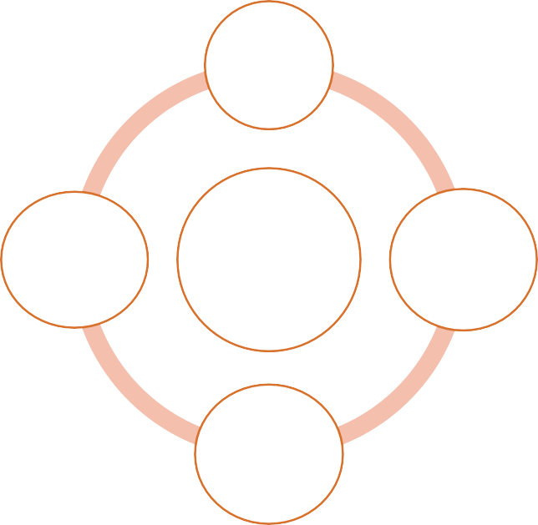
- The first K is for – what is the problem? (kyaa).
What is
the Problem
Where
are the
resources
Integrated FNHW
Micro-plan
Underlying
Causes of the problem
Probable
solutions
- The second K is for - what are the under lying causes to these problems? (kaaran)
- The third K is for – what steps need to be taken to address these problems? (kaise karein)
- The fourth K is for – where are the resources to resolve these problems. (kahaan se sansadhan laayein)

There are certain activities to be conducted with the group to bring out responses on each of these “K” questions, the facilitator should familiarize itself with these activities beforehand. These activities can be a part of a separate detailed FNHW training for CLFs. Details of activities are in annexure 3.

Another tool that can be used is explained below, this is mainly to identify the FNHW services available and the gaps in these services.
- Tool 2 - Participatory Planning and Action (PPA) Triggering Process with Community Institutions
- Map current FNHW services and entitlements in the village
- Assess the access and utilization of services and entitlements using a scoring system to identify gaps
- Prioritize services and entitlements for improved coverage, based on identified issues
- Prepare a plan of action for enhancing use of these services and entitlements which the CLF can take up

This process will be done through a simple process called triggering activity
For the Facilitator
- The importance of triggering process plays a crucial role in improving the demand generation and behavior of the communities and SHG households.
- Triggering, as the name suggests is anything that evokes action. The process orients households on different FNHW services and entitlements which are provided by different line departments.
- Through participatory assessment, community will know the difference between provisions of FNHW related services versus actual status of service delivery which they are getting in their village.
- Hence, it is to make people understand and aware about the actual situation of government services and entitlement on what they are entitled for and the service gaps.
- There are WAVE / WEB diagram activities which are PRA tools, that should be conducted with the community members to have a comprehensive plan. Key members of the community along with service providers are to be invited during this activity.
- In the plan, accountability of each stakeholder including community members is defined very well.
- Once the plan is developed, in the larger group and in the monthly meeting of VOs, the progress against the plan is reviewed.
- Details on the process and how this should be conducted is given below
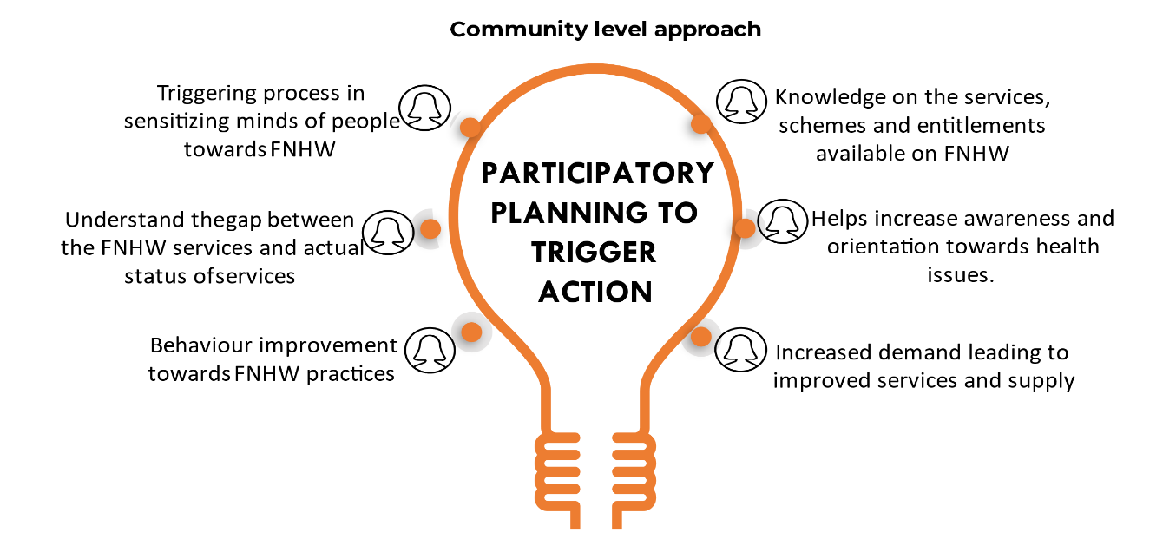
- This requires collective action and prioritization through scoring exercise as illustrated in the figure.
- The situation analysis, in the context of the availability of various schemes and services and their access/reach to the target community is done through a rigorous participative process.
- This starts with the orientation on various health and nutrition-related services and entitlements which are provided by the different departments.
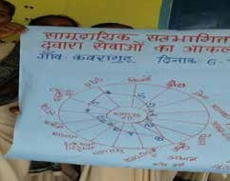
- Probe through discussions with the group on the actual services being provided in their area and identify the gaps in service access and availability.
- The preparation of the scorecard based on availability and accessibility of the services is to be done through a participatory process.
- This is done, with the help of tools that shows the current situation by the scoring system (0-10) with 0 being lowest and 10 being highest and identify the gaps of each service delivery.
- The Resource person should nominate one of the CLF / VO member or President to facilitate this exercise.

The tool should be explained with the group, however the exercise should be part of the proposed detailed CLF training
It is important for the facilitator to know that processes on activities like micro planning and triggering should be understood properly. However, these processes need to be adopted based on the identified FNHW issues for a particular CLF. Micro plan is primarily to understand the problem, causes of the problem and possible solutions whereas triggering will be to identify FNHW services related gaps in the area and what action can be taken for the same. These processes should be accordingly applied.
- Integrating Gender - Involving men and other family members to address gender issues in FNHW
Objectives:
- To identify underlying gendered causes of FNHW problems
- To recognize that gender barriers impact a woman’s ability to access health services.
- To enable participants to recognize and see gender issues or any discrimination
- To identify appropriate platforms and activities for family members and male engagement and social influencers.
- Build ownership over and take action on these issues through male engagement

Gender is a social construct. They are a set of expectations, roles, and behaviors from society. It is given by people around us. Gender transformative approaches are interventions that create opportunities for individuals to actively challenge-
    - i) gender norms
    - ii) promote positions of social and political influence for women in communities
    - iii) address power inequities between persons of different genders by engaging men and family members
      - These interventions address both improving health and changing negative gender norms
      - Women are more than just beneficiaries of services. It is important to think about the underlying dynamics in the household that impact on women’s rights to access and use nutrition and health services.
      - It is important to address roles and responsibilities of men and family members to break gender barriers and support women in accessing care and services
      - Start with involving men and family members into the conversation around food, nutrition, health and WASH within the community
      - This can be done by improving decision making among women within the household, improving mobility and access to services, supporting within the household for daily care activities, improving access to healthy diet and equitable distribution within the household.

The group should be made to understand the societal gender construct through certain activities and the facilitator should familiarize itself with these activities beforehand. Details of the activity are annexed and should be taken up during the CLF training on FNHW
After an understanding is made on the tools that should be used for developing an action plan, the group should understand the role of communication and decide on the use of SBCC resources for undertaking various activities

Session 4: Social Behavior Change Communication (SBCC)
- SBCC is the strategic use of communication approaches to promote changes in knowledge, attitudes, norms, beliefs, and behaviors.
- After diagnosing the problem, its causes, and probable solutions through use of micro planning and triggering, SBCC approaches provide comprehensive set of tailored interventions that promote the desired behaviors among target populations.
- Based on the issues identified and prioritized through visioning and other exercises, the key SBCC activities that will be planned are rolling out of training modules in SHG meetings, home visits for target population, peer counselling and community events and campaigns.
- Based on the situation and problem, one or more of these activities can be chosen as part of the plan.
- To support implementation of these activities, a number of resources are developed and available as FNHW toolkit.
- CLFs can make use of these materials and should select them based on the SBC activities listed in their plan. For example, if the CLF decides that Home Visits are required to deal with a particular issue, counselling card is to be used as an IEC tool for this activity.
- This resource material is available on FNHW technical as well as operational issues.
- Materials have been developed on 17 FNHW themes, list of which is annexed to the document.
- The CLF should use materials based on the themes selected for CLF and refer to the Standard Operating Procedures as required.

The list of SBCC and resource materials in the FNHW toolkit is as below –
Standard Operating Procedure Booklet- to provide detailed guidance on operational and programmatic components
Facilitator Guide for Trainer- to facilitate trainers in rolling out sessions on FNHW
Flipbooks for Trainers to use during SHG meetings
Module on Health Seeking Behaviours and Immunity Building
IEC Materials for home visits, community events, etc.
  - Posters – for display during community events and awareness generation
  - Banners – for events like campaigns and rallies
  - Stickers – to serve as reminders on key messages
  - Counselling Cards – to be used during home visits and smaller interactions
Presentations for orientation of state/district/block managers and CLF/VO level SAC members
Community Mobilisation Videos on various issues
Use of these materials is subject to prioritizing themes, contextualizing, translation, phase wise use and implementing as per State FNHW Operational Strategy.
Session 5: Review and Monitoring
- What and How to monitor
- Based on the FNHW plan, specific indicators are to be defined that will be reviewed and monitored at regularly defined intervals by the CLF / VO / SAC / SHG members.
- The Resource person / facilitator should initiate discussion with the CLF group and ask what should be reviewed based on the issues identified, the CLF plan and priorities that will be taken up for action.
- The CLFs should identify who at each level will monitor and capture the required information for the reviews.
- Each CLF will list the indicators to be reviewed, explain the meaning of indicators, how to measure and the frequency of data capture.
- These indicators need to be reviewed on a periodic basis and responsibilities on who will review, at what level and what frequency should be decided during the planning.
- Activity matrix (annexed) and the list of key activities given below for Model CLF’s should be referred by the facilitator and used as a probing tool for listing these indicators.
There is a web application being designed for capturing data at Model CLF level, orientation on this application should be planned by the facilitator. In the app, the suggested list of FNHW indicators to be collected at CLF and VO level is as follows –
CLF level
1 | Number of CLF SAC trained on FNHW
2 | Number of CRPs trained on FNHW (Session wise)
3 | Number of FNHW Enterprises within the CLF
VO Level
VO reviewed by CLF in the reporting month?
VO initiated FNHW activities
VO organized community events (Exclusive of Poshan Abhiyaan)
Did ASHA/AWW participated in VO meeting
Has VO SAC been trained on FNHW
Have VO OB been trained on FNHW
Has VO (VO SAC) participated in VHSNC/JAS meeting
Has VO SAC/CRP participated in VHSND
Has VO conducted monthly review meeting on FNHW
Number of SHGs initiated FNHW activities
Number of SHGs conducted monthly meeting on FNHW
Number of SHGs covered FNHW session
Number of SHG women oriented on FNHW sessions
No. of SHG Households with Agri Nutrition Garden

The format below can be used for review of activities, the activities mentioned in the format are indicative, CLFs should mention activities as per their plan -
Activities | Current progress as per the FNHW Action Plan |  | Actions to be taken
Activities | Target | Achievement | Actions to be taken

Session 6: Preparation and consolidation of Action Plan
Session Objectives:
- The CLF leaders will discuss the strategies, interventions, associated activities, timelines and responsibilities of different actors (EC sub committees, VOs, SHGs, other stakeholders) to prepare an annual action plan for FNHW, in consultation with resource person / facilitator.
- This will stem from the discussions and exercises conducted with the group in previous sessions.
- The participants should be able to see the plan as their own plan with their suggestions incorporated and resolve to work towards it through their pledge and defined roles.

Session details:
Resource Person/Facilitator will support in designing activities to eliminate internal external factor responsible for current state and CLF will make an annual plan around those activities:
Format for Developing FNHW Plan
Name of the Block: Name of the Village:
Name of Panchayat: Name of VO: Name of CLF: - ______
SN | FNHW issue | Causes | What will be done | How will it be done | Who will do it | Timeline

Signature of CLF President / representative
Name of CLF: Date:
After the plan is developed and activities are defined, the CLF should prepare a detailed time plan in the form of a Gantt Chart. An example is given below with some indicative activities.

Format for CLF level FNHW Gantt Chart

Name of the CLF:_______________Name of the Block:

Duration of the Plan:

Plan and execute capacity building efforts for CLF/VO members/CRP on FNHW components (e.g. developing training plan and organization/coordination for training) | Q1 |  |  | Q2 |  |  | Q3 |  |  | Q4
 | M  1 | M 2 | M 3 | M  4 | M 5 | M 6 | M 7 | M 8 | M  9 | M10 | M 11 | M 12
Support to VOs for organizing community events/campaigns
CLF participating in activities/celebration of events organized by other departments (ex- POSAHN Abhiyaan, Swachhta Abhiyaan etc.)
Meeting/coordination with AWS- for linkage and improved uptake of THR by SHG families, growth monitoring, SAM identification etc.
Meeting/coordination with PRI member- for linkage with Food and Pubic Distribution System for improved access of SHG families to PDS
Meeting/coordination with livelihood CRP/BPM- for establishment of nutri-garden, backyard poultry, goatary in SHG households
Meeting/coordination with CRP/BPM for promotion and establishment of FNHW enterprises (if planned)
Organizing/participating in quarterly convergence meetings with Anganwadi Supervisors and ANMs
CLF approving Vulnerability Reduction Plan (VRP)
Reporting on FNHW MIS
Conducting review of FNHW activities
CLF organizing felicitation ceremony
Consolidation and inclusion of FNHW issues in next year planning process (eg. issues emerged from Triggering process, Swabhimaan’s IMP process, VPRP and VRP etc.)
Any other activity (as planned by CLF)
Note: CLF should clearly define each proposed activity. The above activities and timelines are indicative only and can be modified as per State FNHW Operational Strategy.

Prepared by (Name and Signature) Approved by (Name and Signature)

List of Annexures

Annexure 1 - Activity Matrix as per the State Operational Strategy

Level | Responsible | Activities | What to track | Frequency
Household | Community Mobilisers (CM)/ Women Activists (WA) | - Promotion of usage of toilet, diet diversity, menstrual hygiene  - Home Visit of target group (TG) (Pregnant Women (PW) /Lactating Mothers (LM)/Children below 2 years) | - Number of Household (HH) having functional toilet  - Number of HH using safe methods of menstrual hygiene  - Number of HH adopted safe disposal of sanitary napkins  - Number of HH adopted Diet Diversity  - Home visit conducted – Yes/No | Monthly
Household | CRP- Livelihoods (LH) | - Agri-Nutrition Garden  - Backyard poultry, goatery, dairy, duckery, piggery etc. | - Number of HH having Agri-Nutri garden  - Number of Mahila Kissan supported for livestock | Monthly
SHG | CM/  WA  (1 CM/WA per 10 SHG) | Social & Behaviour Change Communication (SBCC) Module Roll out -Sessions on FNHW issues | - Number of SHGs trained  - Number of SHG members attended  - Topic of session discussed | Monthly
SHG | CM/  WA  (1 CM/WA per 10 SHG) | Follow up in subsequent meetings  Invite ASHA/AWW in any one meeting | - Number of SHGs discussed FNHW issues in the follow up meetings  - ASHA attended-Yes/No  - AWW attended-Yes/No | In 1 of the 3 remaining weekly meetings
VO | SAC & CRP FNHW  (1 CRP per 10 VO) | - Develop SHG wise FNHW plan | Plan developed – Yes/No | Annual with monthly/quarterly break up plans
VO | SAC & CRP FNHW  (1 CRP per 10 VO) | Line listing – Identification of Target Groups amongst SHG members & HH (PW/LM/Children below 2 years) | Number of TG – (PW, LM, Children below 2 years) identified  Track each identified PW/LM/Children below 2 years (mothers/care givers) for participation in SBCC sessions, VHSND, CBE (ICDS), diet diversity, home visit, Agri-Nutri garden, farms | Monthly  Monthly
VO | SAC & CRP FNHW  (1 CRP per 10 VO) | Community based events (in sync with the SBCC topic roll out) [a. Demonstrations -Hand Wash, Recipes, Food Groups, Safe drinking water etc. b. Campaign] | Number of CBE conducted  Type of CBE-Demonstration, campaign, Rallies, Nukkad natak etc.  Topic of CBE demonstration (drop list)  Number of SHG attended in CBE | Monthly
VO | SAC & CRP FNHW  (1 CRP per 10 VO) | Coordination meeting with ASHA/AWW on - VHSND/CBE planning/sharing list of high-risk pregnant women, SUW children, SAM/Campaign | Meetings conducted – Yes/ No  Number of high-risk pregnancies, Severe Under Weight children, Severe Acute Malnourished Childern identified & supported  Nature of support-VRF, LH, Nutri garden, farm, follow up, any other  SAC participated in VHSND planning meeting | Monthly  As per case to case basis
VO | SAC & CRP FNHW  (1 CRP per 10 VO) | Mobilize TG for VHSND/CBE (ICDS specific- Annaprashan/ Godhbharai | VHSND/CBE organized-Yes/No  Number of TG participated | Monthly
VO | SAC & CRP FNHW  (1 CRP per 10 VO) | POSHAN Abhiyaan -Event Calendar | Jan Andolan portal maintained by MoWCD (as per the portal) | As per Calendar
VO | SAC & CRP FNHW  (1 CRP per 10 VO) | Other Ministry’s Abhiyaan-Fit India etc | Number of activities conducted  Topic of activities  Type of activities -Rallies/Nukkad natak etc.  Number of SHGs participated | As per directions from Ministries
VO | SAC & CRP FNHW  (1 CRP per 10 VO) | Review of FNHW activities-  (SHG level & HH activities) | Meeting conducted – Yes/No  Issues discussed – Text  ATR submitted – Text | Monthly
VO | SAC & CRP FNHW  (1 CRP per 10 VO) | Review CM /AW performance | Number of cadre (CM/AW) reports approved | Monthly
CLF | SAC & Master Trainer (MT) -FNHW  1MT per 5 GP (roughly 40-50 VOs) | Develop VO wise FNHW plan | Plan developed-Yes/No | Annual with quarterly break up
CLF |  | Training of CM, CRP, SAC, SHGs, VOs and CLFs | Number of VOs having trained cadre  Number of SAC-VO trained  Number of SAC-CLF trained  Number of SHGs trained  Number of VOs oriented  Number of CLFs oriented | As per training plan
CLF |  | Coordination meeting with Supervisor, ANM, other departments as required | - Meeting conducted – Yes/No  - Issues discussed – Text  - ATR submitted – Text | Quarterly
CLF |  | Promotion of FNHW enterprises (CRP-EP) | Number of FNHW enterprises established – (Form) | Biannual
CLF |  | Review of FNHW activities | Meeting conducted – Yes/No  Issues discussed – Text  ATR submitted – Text | Monthly
CLF |  | Review CRP performance | Number of CRP report approved | Monthly
CLF |  | Awards & Recognition | Number of SHGs & VOs awarded | Annual

Annexure 2 – Themes on which FNHW resource materials are available
Flipbooks, Counselling cards, Posters and Stickers are available on the following FNHW topics and can be accessed.
- Linking Livelihood with FNHW
- Malnutrition and 1000 days
- Maternal Nutrition
- Infant and Young Child Nutrition
- Ante-Natal Care
- New Born Care
- Management of Anaemia
- Family Planning
- Family Diet Diversity and Balanced Diet
- Adolescent Nutrition and Health
- Nutrition and Health during NCDs (Diabetes, Hypertension & Obesity)
- Nutrition and Health for Elderly & Disabled
- Nutri-Gardens
- Public Distribution System and Take Home Ration
- Hygiene Related Behaviors (Toilet use, Handwashing, Personal Hygiene and Food & Water Hygiene)
- Menstrual Hygiene and related issues
- Management of Household Waste
Annexure 3 – Activities for Microplanning

ACTIVITY 1: To understand the problem around FNHW
Materials: Problem cards (there will be cards available for various FNHW issues, some examples ae shown here)
Steps:
- Show the problem cards to the participants and facilitate discussion using the following questions –

Q1. What do you see in the photo?
The photos will depict different problems attributing to FNHW issues. For example, if the group has identified malnutrition among pregnant and lactating women as some of the problems these set of cards will be used

Participants’ response: We see the picture of woman suffering from anemia in pic-1, mother of many children in pic-2, a short height pregnant woman in pic -3 and the picture of tired pregnant woman with excessive workload in pic-4.

Message for facilitator: It is important for the facilitator to generate discussion on all the selected problem cards and provide answers to questions as prevalent in their area.
Pic – 1 Pic-2 Pic-3 Pic-4
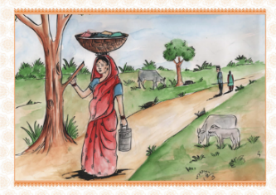
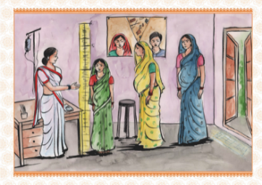
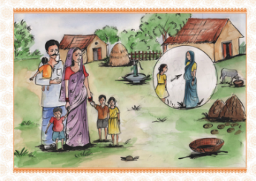
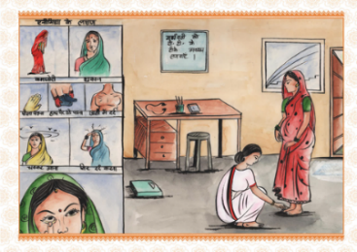
Q2. Do we see such a situation in our community/village?

If participants respond as yes to these situations as common in their community/ village, then the facilitator may take the discussion further, asking few relevant questions like:
- Do you find the situation prevalent in the entire village or in some specific tole/ communities?
Participant’s response: Yes, we see many pregnant women and mothers in our village as shown in the pictures.
- Which community/tole you think is the most affected by malnutrition issues?
Participant’s response: Those communities who have very less income or whose households are situated far from service centers.
- In which tola (hamlet) / communities, do you find the malnourished women the most?
- Does this situation prevail for the entire year or for any specific period of time in the year?
- Can you identify yourself with any of the women presented in the cards?
Participants’ response: Yes with pic-3 and 4
- Can you assess your status of malnourishment yourself?
Participants’ response: No, since we are not aware of methods to assess our health and nutrition status.

Message for the facilitator: Then, the facilitator can also introduce the participants with various methods for assessing their health status (weight, height, Hb level) available in service centers and she can further counsel the nutrition-at- risk group (women who are pregnant below 20 years of age or thin/ underweight/ overweight or short in height) on the importance of routine health assessment during pregnancy and also inform that the health assessment is provided in service and resource centre (AWC/ PHC) in their village.

Q3. Do all households have access to government services (like institutional delivery, AWC THR, ASHA outreach, VHSND etc.
Participants’ response: Some of us are not able to get access to the mentioned services.
Here, the facilitator should take informed decision whether to go ahead with the next step or not. This will depend on the participants’ interest for identifying the gaps in FNHW services.

Message for the facilitator: Then the facilitator should elaborately discuss on the available government services for pregnant women and mothers, such as- Anganwadi services, PDS, ANM services, VHSND etc. Then, the facilitator should further probe into the issues, asking the following questions:
- Which households do not have the access to the above government services?
- Can we make a resource mapping/ Nazari naksha in order to understand the above situation better?
Participants’ response: Yes
Message for the facilitator: Then the facilitator can facilitate the process of preparing a Nazari naksha on the floor, depicting the roads and main service and resource centers available in the village. The activity will be undertaken by the participants collectively. The facilitator should stir the discussion on the settlement pattern, the distance between their households and service centers, access to all-weather road etc among the participants while undertaking the activity.
ACTIVITY 2: To identify the root causes of the problems (income and behavioral constraints, myths, and practice) around FNHW
Two games are mentioned here. The facilitator can decide which game to play, either or both, with the participants based on their issues.
Materials: Daily food intake chart, food group photos, Food myths chart

The facilitator should identify women who are thin, look tired or anaemic or are of short height for this game.

GAME 1:
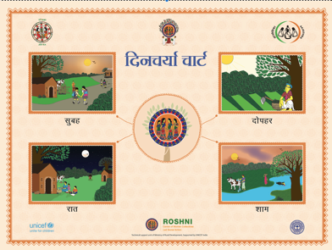
- Place the Daily food intake chart and food group photos in front of the participants.
The daily food intake chart will be prepared clockwise where 24 hours will be divided into morning, noon, evening, and night. The facilitator will use photos of different food groups with the participants.
- Ask a few volunteering participants to share their dietary intake in the last 24 hours – morning, noon, evening, and night
For example if the response is: Morning- Tea; Noon- Chawal, dal; Evening-Nil; Night- Roti, sabji then…
- Ask the participants to place the food group photos on the chart according to their hour of consumption during the day
- Ask the following questions:
  - Ask all the participants to reflect on the daily dietary intake shown on chart (sufficient/ in-sufficient)
Participants’ response: in-sufficient. If the respondent gets confused to reply, then the facilitator will ask other respondents to reflect on the above dietary intake.
  - What are the reasons behind the insufficient dietary intake?

If the respondent is unable to give reasons, then the facilitator may help her in replying, by further probing, like:
- Is this because of lack of income/ low resources/ behavioral constraints/ other reasons?
- Do you have this diet because you don’t have enough to eat?
- Do you have enough to eat but you prefer to eat less?
- Do you have any restriction in having meal?
- Do you get enough time to have frequent meals during daytime?
- Do you decide the items for your meal or other members of your family?

Note: The facilitator should write the replies on the chart paper to identify the causes.

GAME 2:
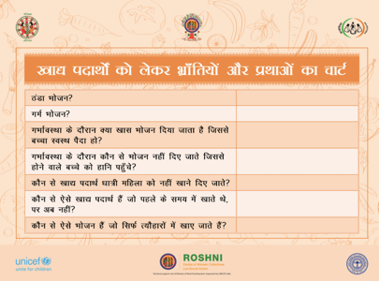
- Place the food myths chart to discuss what are the myths and practices associated with food. Against the questions asked on the chart, place the photos of the food groups as per your understanding.
The questions are as following:

  - Which of the following food groups is considered ‘cold food’?
Participant’s response: yogurt and vegetables, especially gourds.
  - Which of the following food groups is considered ‘hot food’?
Participant’s response: papaya, banana, coconut, pineapple, red chillies, jackfruit, meat and egg
  - Which of the following food groups are considered to be healthy during pregnancy?
  - Which of the following food groups is considered to be harmful during pregnancy?
  - Which of the following food groups are considered to be harmful for lactating mothers?
  - Which of the following food groups were used to be consumed earlier but not now?
  - Which of the following groups are consumed during festive seasons?

Message for the facilitator: The answers may differ based on communities, but the facilitator should be mindful that without harming their beliefs, should encourage the participants to share their views and write down the answers on the chart paper.

- Discuss the reasons with the participants for each question

Participant’s response: Jackfruit, papaya- harmful during pregnancy
Egg- the baby may smell stinky
Message for the facilitator: In this context, the facilitator should also have knowledge on common myths, behaviour and practices prevalent among the particular communities in order to facilitate the discussion and can ask few more questions to probe into the issues. The facilitator will write down the reasons on the chart paper alongside the photos of the food items.
- In addition to the questions in the chart, following questions can be discussed:
  - What are food groups available in the households throughout the year?
  - Which are the food items that are produced but not consumed within the household?
  - What are the food items grown/available within the households?
  - What are the food items that are brought from the market for household consumption?
Message for the facilitator: These questions will help the facilitator to identify the causes of the problems- whether they are behavioural, myth related or due to lack of resources.
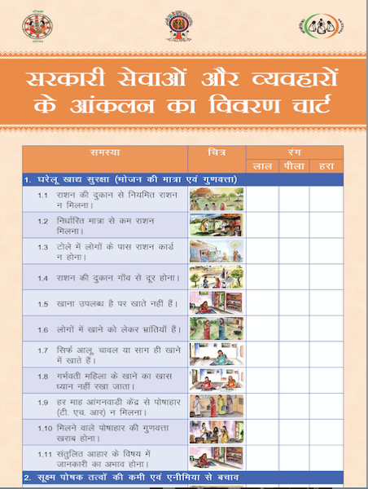
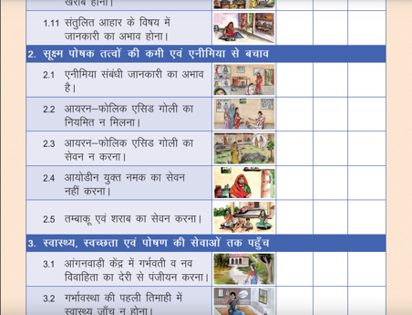
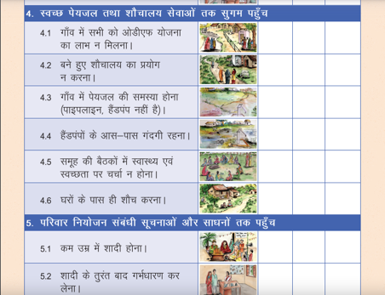
ACTIVITY 3:
To prioritize the problems related to access to government services and behaviors around FNHW practices.
Materials: Government services and behaviors chart, problem cards, 3 colour stones (red, yellow, green)
Steps:
- Place chart in front of the participants with all the list problems and corresponding problem card
- Show each problem card and take voting from all the participants to show the severity of the problem within their community
The facilitator can ask some questions to help the participants collectively decide in prioritizing the problems –
- Do you think that household food security can be enhanced if some problems are addressed?
Then the respondents will start voting.
- For this voting, participants will use coloured stones – red for severe problem, yellow for mild problem, green for normal status.
- At the end of the voting, identify the top severe problems as priority.

The participants will identify the top severe problems on the flex/chart based on the colour and number of the stones.

ACTIVITY 4:
The action plan is discussed in detail in session -6 – ‘Preparation and consolidation of action plan’ of this module.

Annexure 4 – Activity for Gender Integration
ACTIVITY: Gender within the household
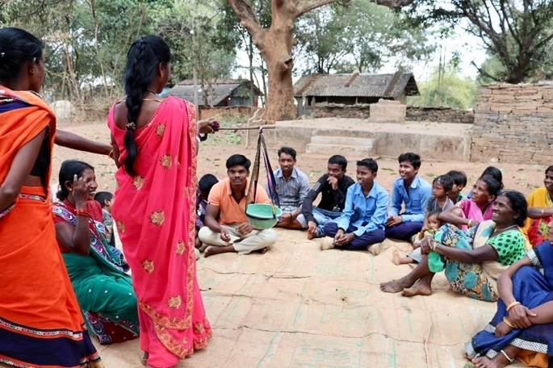
Objective:
- To understand division of labour among women and men
- To make women’s work visible
- To build an understanding of the burden of work faced by women and the impact of gendered roles on the health and nutrition outcomes (like access of services, adoption of appropriate behaviours)
Materials needed: A bunch of pebbles or stones, question list, chart paper with two columns, one with a drawing to depict a man and another with a woman, markers/pens
Process:
- Place the chart paper on the floor.
- Ask the participants to identify which section of the chart is for the man and for the woman
- Distribute pebbles/ stones to the participants
- Tell them that they need to start listing out the tasks that they do throughout the day
- Each to place a pebbles/ stone for each task. Facilitator to note down tasks mentioned on a chart.
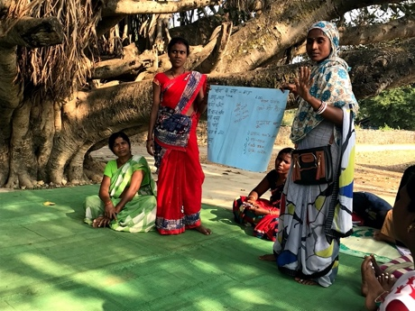
- Take discussion forward based on the pile with a larger number of stones

Instructions:
- Ensure tasks mentioned are tasks that produce ‘value’. So, brushing teeth or bathing for instance, are not tasks.
- Ask specific questions:
- Are women’s tasks are considered work?
- Ask why or why not?

Debrief: The work and numerous tasks that women do within the household are not recognised as work. It is assumed that this is something that comes naturally to women and it is their “job as a women” or this is “mahila ka kaam”. Due to this fact, it does not have to be paid for. Our society devalues such work done by the household. As a result, not only are women’s contribution to their homes invisible, but it also means they have a lesser say in household decisions, access to resources and mobility. Because of this norm, women are not able to receive enough support within the household by the family members. This leads to social conditioning that impacts their health, nutrition and overall wellbeing.

