Module : Planning with Resource Person/Organisation (Rights and Entitlement)
Session | Topics covered | Duration
Session 1 | Introduction to participants | 10 min
Session 2 | - Understanding CLF’s Vision and targets in general and specific to Rights and Entitlements  - Enhancing CLF’s Understanding on Rights and Entitlements, Difference between Rights and Entitlements | 50 minutes
Session 3 | - People’ Forums to access rights and entitlements  - Importance of working with Panchayat and Departments  - Gram Sabha as a people’s platform, its use and impact | 75 minutes
Session 4 | - Planning - Collective planning through VPRP and GPDP and participation in functional committee  - Monitoring - Ensuring implementation through PRI and departments  - Role CLF can play in Gram Sabha | 60 minutes
Session 5 | - Preparation of Action plan (including support required from thematic experts)  - Presentation of Plan  - Concluding practice /Mock exercise  - Pledge | 60 minutes
Objective of the training:
At the end of the training the participants (EC members of the CLF) shall go back with:
- Enhanced understanding of rights and entitlements, its concept, major stakeholders and the methodology to deliberate and converse with these stakeholders.
- Enhanced understanding about what needs to be done (Aim) to address challenges faced by the community in dimension of rights and entitlements
- Enhanced opportunity to evolve an understanding and commitment to how to (strategy) achieve the same.
Preparations before the training:
- The charts depicting the vision as well as the change vectors should be prepared beforehand.
- The results frameworks as prepared by the CLF EC in their previous strategic meetings needs to be depicted in charts for ready reference in this meeting.
- The facilitator should essentially go through these charts before initiating the meeting process.
Session 1: Introduction to participants
Duration: 10 minutes
Session Objective:
- Helping the participants and invited resource persons get familiarized with each other
- It will also help in breaking the ice as there will be some unfamiliar faces in the meeting/training

Session 2: Introduction to the Rights and entitlement dimension and related decisions of the CLF and enhancing basic understanding on rights and entitlements
Duration: 50 minutes
Session Objective:
- The session would see the sharing of the discussions undertaken by the CLF regarding the Rights and entitlement vertical and why do they consider it as a priority dimension.
- The Resource persons shall get an understanding of what all has been discussed in the previous iterations of the CLF as far as rights and entitlement is concerned
- Enhance the CLF’s understanding on Rights and entitlements and the difference between what is a right and what is an entitlement
- Sharing of few schemes and its benefits
Session Details:
The CLF president on invitation by the resource person shall share their overall vision.
The facilitator may ask what all themes or change dimensions they have prioritised to work on. She may also be asked to share briefly as to why they have decided to work on rights and entitlements dimension.

The facilitator would then ask the leaders to share the quality life dimensions and indicators identified by them to achieve this vision. The CLF leader may also be asked to present the work they have done so far with regard to rights and entitlement which can be considered as the facilitative conditions.

The facilitator would then take up the opportunity to discuss the difference between what is a right and what is an entitlement. To gauge the understanding of the CLF EC members, the facilitator may ask them what they understand by the terms – rights and entitlements.

The members would be divided into two groups and will be given two placards – written like ‘entitlement’ and ‘rights’ on them. The groups can be asked to write down a set of statements that they feel are pressing needs of the community. The facilitator would then read out a set of statements mentioned by the members and ask them to raise one placard to categorise the statement as rights or entitlements. Thereafter the facilitator would read the below given statements that may not have already been stated by the participants.
The statements are as follows:

- Women deserve equal space and opportunities to express their opinions and views and participate in decision making bodies. - Rights
- Government of India mandates one-third reservation of women in local governance bodies to ensure women participation - Entitlement
- Children irrespective of gender should equally be allowed to attend schooling and take education. - Right
- Government ensures girl child education by giving scholarships to girls for attending school. - Entitlement
- Every individual should have access to proper healthcare facilities - Rights
- Ayushmann Bharat scheme provides insurance and access to primary healthcare to each and every individual and covers the financial costs for treatment - Entitlement
- Every individual should get work and livelihood opportunities with proper wages near their village -Rights
- MGNREGA mandates to provide work to every citizen in their own village to avoid urban migration and minimise exploitation of labour - Entitlement
- Every citizen should have access to a proper shelter - Rights
- Government has launched Pradhan Mantri Awas Yojana for providing shelter - Entitlement
- Children irrespective of their gender should have a life full of dignity and respect - Rights
- Sex selection during birth has been banned by the Government in India - Entitlement
- Children of all age, sex, caste, religion, ethnicity should get proper nutrition and healthcare - Rights
- Anganwadis in all villages under ICDS Scheme provides proper nutritious food and basic health check ups for all children - Entitlement
- Every household should have enough food for the members of the family and nutritious food should be accessible to us - Rights
- Government gives subsidy to each one of us to buy ration at a subsidised rate so that every poor household can have food at an accessible rate - Entitlement
Following this, the facilitator will explain the terminologies one by one.
Rights underline that the constitution is committed to the protection of all irrespective of their social, economic and ethnic background. They are not attributed to any scheme or government. Rights is universal
However, entitlements are welfare measures attributing to a particular scheme of the government targeting a set of people. Entitlements are constrained by budget.

Session 3: Peoples Forums to get Rights and Entitlements-importance of working with GPs

Session objectives:
1.Understanding what all different people’s forums available in the area and their objectives
2. Understanding Gram sabha as a forum

Session details:
Gram Panchayat and Gram Sabha ::
Facilitator will share about people institution available for villagers (SHG/VO/CLFs) through which they can raise their demand and create pressure to ensure timely delivery of their rights and entitlements and facilitator will also discuss other constitutional forums like PRI and how that is the core institution through which entitlements and rights can be achieved.
To gauge the understanding of the participants, the facilitator may ask the following questions.
What is a Gram Panchayat?
Who are the members of the Gram Panchayat?
What are the roles and responsibilities of the Gram Panchayat?
What does the Gram Panchayat in your village do?
The facilitator can then briefly explain the concept of Gram Panchayat.
- The idea of Panchayati Raj is based on community participation and collective decision making i.e. self-governance at the local level.
- The objective behind establishing this system was to take democracy to the village level, by delegating powers to the people at the grassroots.
- Democracy is characterised by the extent and ability of people to participate in the governance process and control the decisions impacting their lives.
- For the realisation of this ideal, there was a general consensus that the Government should be as close to the people as possible.
- Elected Representatives are members of Gram Panchayat which is headed by a gram panchayat president/pradhan. A representative of each ward who are ward members are also a part of it.
- The GP plays a crucial role in shaping the development processes in the village while addressing the diverse needs of the community.
- The GP is involved in implementing schemes such as MGNREGS and ensuring 100 days of employment to provide basic civic services such as drinking water, health education etc.
- Hence, the GP directly impacts the lives of the people in the community making it important than ever.
- The citizens can depict a clear picture of their village i.e. the issues they face, their needs and aspirations.
- Using this local knowledge and the interests of the citizens, solutions to address needs and aspirations can be drafted in an effective and efficient manner with the joint efforts of the elected representatives and citizens.
Gram Sabha
The facilitator can open up the conversation by showing the poster.
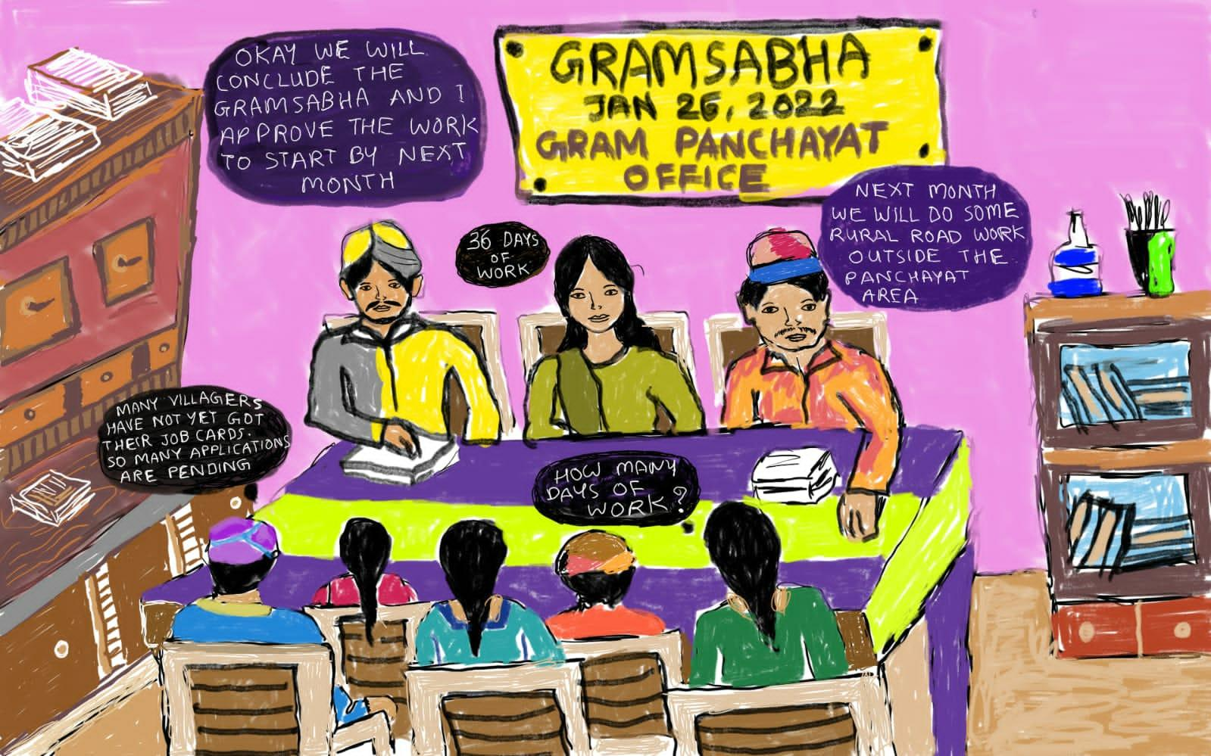
Triggering Questions:
- What is happening in the picture?
- Have you witnessed such a scenario in your Panchayat?
- What do you think should be the situation?
- What can CLF do to ensure the ideal situation?
Facilitator:
- Gram sabha is the lowest unit standing as a part of the local governance
- Gram sabha is essentially the formal democratic platform for the people to have
their representation, to make their voices heard, to demand the constitutional rights, to become aware about their entitlements, and to become an active participant to their own process of governance and development

The following knowledge pamphlet handout could be distributed to the participants and then discuss about the basic provisions.

Based on the handout serving as an IEC material, the discussion will be on-

- Idea of Gram Sabha
- Quorum
- Powers and duties of Gram Sabha
- Venue for the Gram Sabha meetings
- Process to be followed
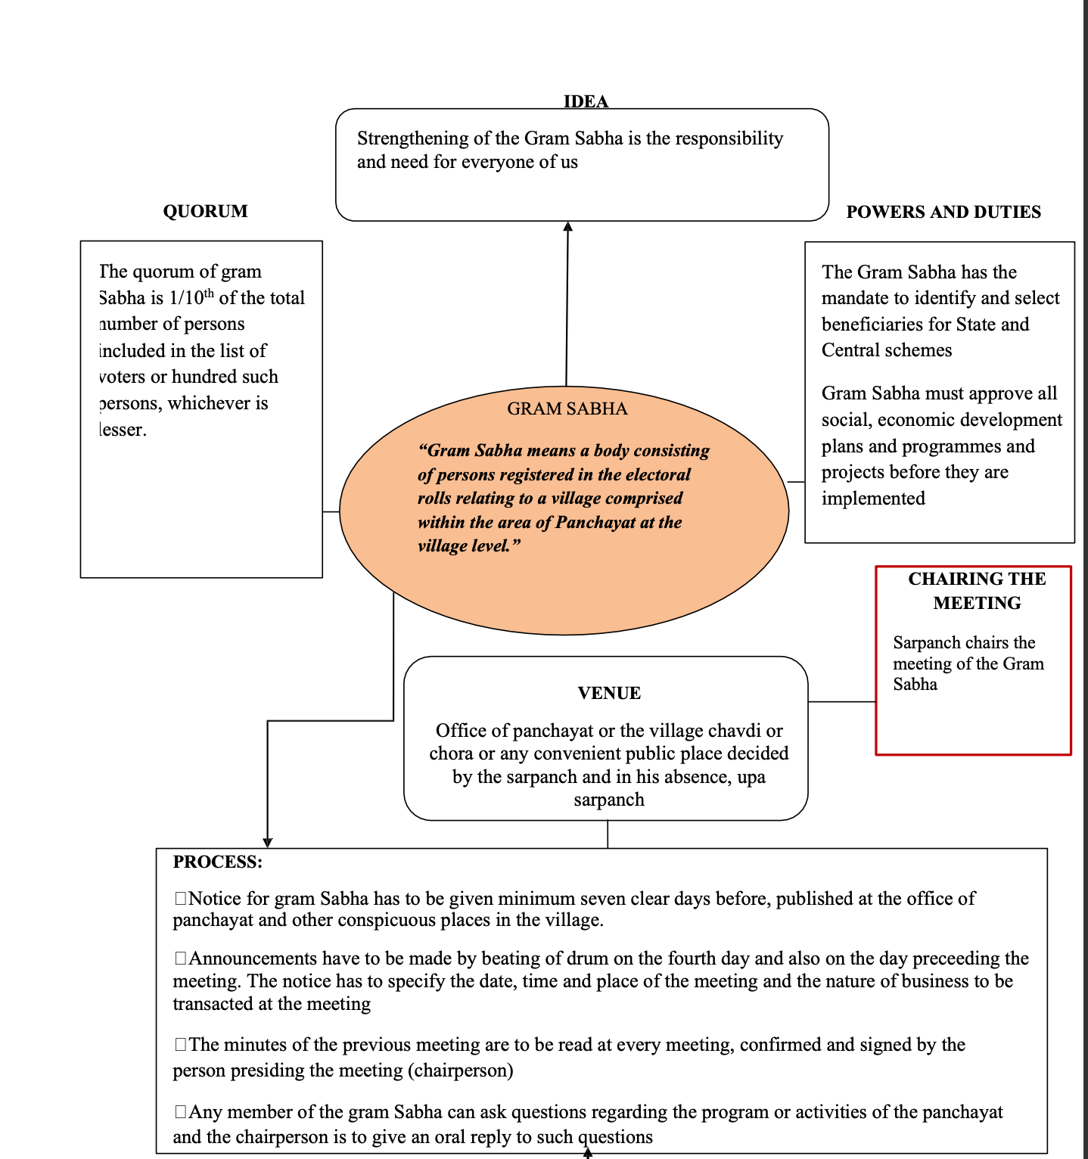
Facilitator Note
The facilitator must discuss all the component of the IEC material in detail to the participants and ensure the grasp the idea of Gram Sabha

Session 4: How to work on accessing Rights, Entitlements and ensure overall development of the Villages under the cluster
(CLF working with Gram Panchayat,departments, Preparation of VPRP for integration with GPDP and Gram Sabha as a platform)
Duration: 75 minutes
Session Objective:
- To compare the potential of a collective towards local development
- To understand the strength and benefits of a collective by participation in Gram Sabha and presentation of demands
- To understand the importance of different collectives in local Governance through preparation of VPRP to be submitted to GP
Session Details:
The facilitator will start off the session by showing 2 posters.
One, showing a situation wherein there is no convergence between stakeholders and the other poster showing convergence.
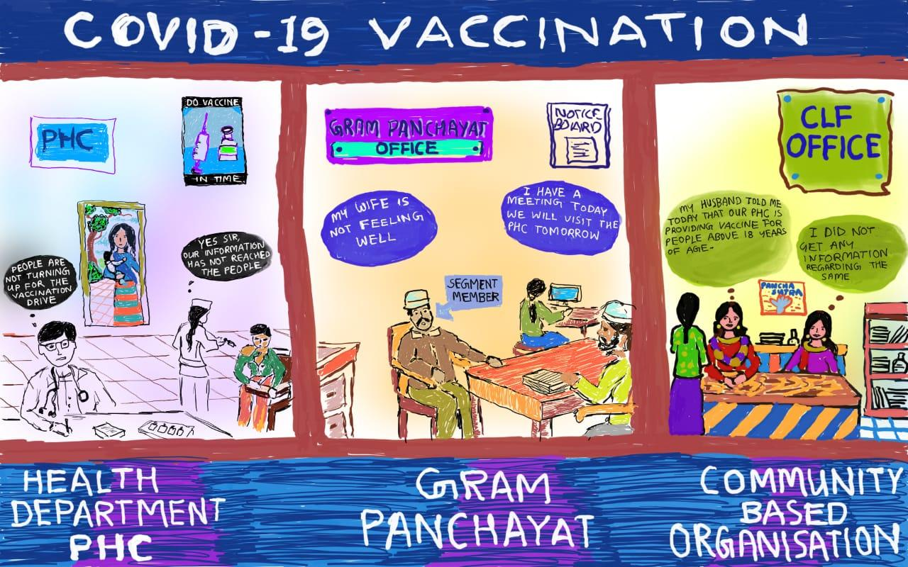

Triggering question:
- What do you infer from the poster?
- Why is it that no one has turned up in the PHC?
- What can Panchayat do in such scenario?
- What can Federation do in such a scenario?
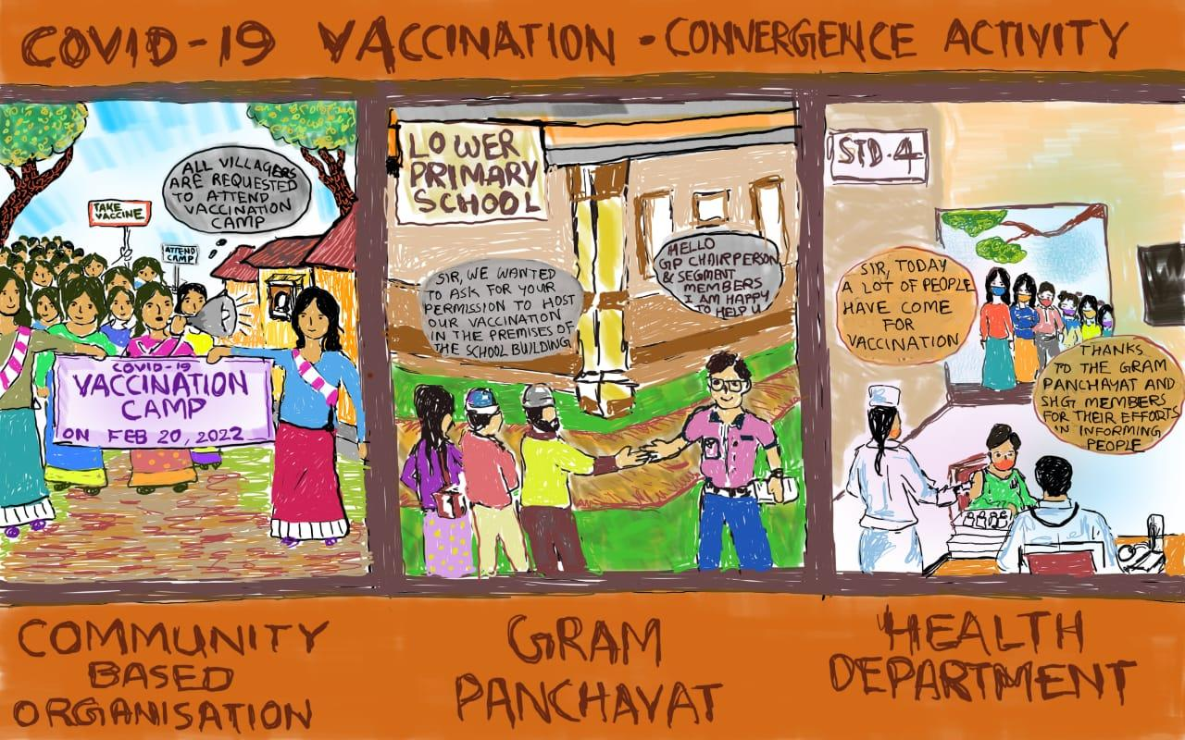
Triggering question:
- What do you infer from the poster?
- What is different in this poster?
- Why do you think the difference was possible?
After collating the answers, the facilitator may collate the responses. The facilitator will then explain the importance of Federation working alongside the panchayat and departments.
- The women’s collectives is the strongest network in the entire Panchayat, and the source of information dissemination about all the government schemes and programmes, ensuring that the same reaches every single household in the villages.
- For local development to take place, it should be community driven and community based.
- Women’s collective can act as a network that engages in a constant dialogue with the governance processes, hence the plan preparation process can be participatory in nature
- SHG members by being part of citizen committee such as Anganwadi Level Support and Monitoring Committee (ALMSC) , School Management Committee, Village Health Sanitation and Nutrition committee can ensure the quality of services being provided in these institutions and can help in monitoring the services.
- By engaging with Gram Panchayat, a sense of citizenship is invoked in the minds of the women collective
From the photo, we can see how the social capital of the federation was utilised to mobilise the community to come forward for the COVID 19 vaccination camp held under the leadership of the health department.
The facilitator should then link the discussion towards what CBO can do to initiate their discussion to work with the PRI and Line departments. The major means or pathway to initiate discussion around local development with the Panchayat is through the preparation of Village Poverty Reduction Plan (VPRP).
The facilitator will gauge the understanding of CLF members on last year’s VPRP Planning and roll out through the following questions.
- Have you heard something about VPRP? (probe further on plan preparation, submission, role of gram panchayat)
- What is your understanding of why we do VPRP?
- Did the CLF assist the cadres in doing VPRP?
- Did the CLF play a role in monitoring the process of VPRP?
- Where was VPRP submitted?
- Did CLF support VOs in conducting consultative meetings with their respective GPs ?
- Did CLF OB members oversee the VPRP consolidation at Panchayat level?
- Did CLF play a role in liaisoning with the department?
- Did CLF review the work of cadres during VPRP?
VPRP is the comprehensive demand plan prepared by the SHG and its federation on topics of entitlement, livelihood, public goods, services and resource development plan and the social development plan.
(The video on Krantinagar may be shown again to brush up the understanding of CLF on VPRP)
CLF being the federative structure of SHG can play an important role in ensuring that the SHGs are motivated to prepare plans, present and submit the plans. CLF can play an integral role in liaisoning with departments and it is essential for the federation to take up the leadership for the same.
The facilitator can ask the CLF to name the major schemes/components taken up under VPRP in a white board. Once the list is noted down, ask the CLF to write the name of the departments pertaining to it. This is to orient the CLF on the names of the major departments which they can collaborate with.
For example,
MGNREGS Job card | Panchayati Raj Department, Rural Development Department
Disability Pension | Social welfare
UJJWALA Yojana | Gas agency
Ration card | Food and civil supplies department
Saubhagya | Electricity department
Animal Husbandry related activities | Animal husbandry department  Veterinary department
Farming activities | Agriculture department  Horticulture department  Forest department
Construction of Anganwadi | Women & Child Development, Panchayati Raj Department, Rural Development Department
Teachers in school | Education department
Facilitator Note
Now that we have discussed importance of working with PRI and departments as well as the ways to work with them, the facilitator can move towards the platform for convergence which is Gram Sabha
Suggestive Role CLF can play with departments:
Consolidate the demand from all VOs under the CLF which could not be met through Gram Panchayat.
Segregate the demand as per various departments
CLF may divide responsibility amongst subcommittee as per nature of department (Eg; Agriculture related demands to livelihood sub- committee, Disability pension related demands to social action sub – committee. Etc.)
One to one meeting with concerned department for submission of demand and understanding further procedure.
Follow – up meetings and updating status in each CLF meeting

Energiser: River Crossing game *( Different game can be played which enhance undertraining on – (जानो knowledge, अपने आप को तैयार करो Skill, आपस में समन्वय बनाओ aur achieve your target )
- Divide the participants into two groups. This game should be played in a large indoor open space.
- Draw two parallel lines 10-15 meters apart .The space between these two lines can be considered as river.
- The river have man eating piranhas, so no one can touch the water.
- Both the team will get 3/4 pieces of A4 size paper , which are represented as rocks
- The team can use these three papers to cross the river.
- If anyone makers contact with water, they will be dead and have to go back to the beginning point. The team in which everyone crosses the river first becomes the winner.
This game is to motivate the participants and to make them realise how to mobilise the community with limited resources. This can act as a linkage point to session 2.

Role CLF can play in Gram Sabha
Process – Hamari Gram sabha – (Vision, current state and role of CLF )

Step 1 ----Facilitator divide participants into small groups ( 5-7 members) and will ask participants to think on the given question and share their vision about an ideal gram sabha
( आप एक ग्राम सभा सदस्य एवं महिला होने के नाते, अपनी पंचायत की ग्राम सभा को कैसे होते हुए देखना चाहते हो) । Each participants will be given 5-10 minutes to think on the subject and then share characteristics of an ideal gram Sabha . One/two members will be selected to participate in the fishbowl discussion.

Steps 2 – Fishbowl discussion (The fishbowl technique is ideal for many situations where a discussion around various points of view is needed. It is also a great tool for training courses and involving participants in discussion around a specific topic. Two circle will be formed, inner circle with one empty chair , this will be formed by selected members from the last sub-group. This group will discuss and finalise the decision points , outer circle will be formed with rest of participants as observers and listeners who can also participate if required by going inner circle, sitting on empty chair and giving input to fishbowl participants and then coming back to outer circle space )

– Facilitator will invite all selected members to form fishbowl and others will sit in the outer circle to observe the discussion, after discussion and finalisation of decision points, facilitator will request fishbowl members to share their decision points with large group.

Facilitator will write down the decision points on whiteboards (Step no 1) then s/he will invite sharing from participants on step 2 question , once step 2 will be completed , facilitator will raise question 3 (Step 3) and write all responses , further this step three sharing will be divided into 2 category

Step 1 (Shared by fishbowl participants) | Step 2 (Current state shared by house/all participants) | Step 3 (factor responsible for current state shared by house/all participants)
How we would like to see the ideal gram sabha | What is happening in gram sabha these days | What are the reasons responsible for current state
All women of the panchayat should participate in the gram sabha | Very few participate in the gram sabha | Don’t know time and place of gram sabha
 | Very few participate in the gram sabha | Don’t know what can be contributed in GS
 | Very few participate in the gram sabha | Shy to sit with male GS members

Internal factors | External factors
Shy to sit with male GS members | time and place of gram Sabha is not being shared
Don’t know what can be contributed in GS
After completing the discussion and categorisation of factors into 2 parts, facilitator will invite suggestions on “how to minimise the factors and what would be role of CLF in minimising the factors)

Facilitator’s Note:
Suggestive roles of CLF
Information dissemination to VOs if special Gram Sabhas are being organised.
CLF can have a major agenda during their meeting where VOs can share their agenda to be put forth in Gram Sabha
CLF can ask VO members to share their experience of participating in Gram Sabha
They can follow up with departments in case, demands were submitted to departments

Session 5 - Preparation of Action Plan

Session Objectives:
- The CLF leaders will discuss their strategies, activities and timelines and responsibilities of diff actors (EC sub committees, VOs , SHGs) to prepare an annual action plan in consultation with resource person/organisation
- The participants will be able to visualise their own ideal gram sabha and resolve to work towards it through their pledge and concrete action plan prepared.

Session details:
Resource Person/Facilitator will support in designing activities to eliminate internal external factor responsible for current state and CLF will make a annual plan around those activities:

Activities | Time from | To | Who will do that
Pre Gram sabha
During Gramsabha
Post Gram sabha
Pre VPRP
During VPRP
Post VPRP
GPDP related
Post GPDP

Once CLF leaders present this plan, the facilitator can ask the following question:
If all preparation and activities planned above will be done by CLF on time then how our Gram Sabha will look like. Then she/he can ask participants to draw a picture of an ideal gram sabha followed by a discussion on characteristics of the gram sabha.

(If time permits, the participants may also be asked to do a mock session of an ideal Gram sabha.)

The facilitator may end the session with the following video
https://www.youtube.com/watch?v=V4bpVzWHW38 - English
https://www.youtube.com/watch?v=Yj5yddWBOyI – Hindi

End the training session with a pledge to ensure the dreamed change GS.

Pledge - Facilitator’s note:

I, _________ (name of member) as a member of _______(name of CLF) hereby take a pledge that I will play an active role in the upcoming Gram Sabhas. I will take the leadership to prepare our demand plan, consolidate and submit in the concerned Gram Sabha. For this, I will ensure that my VO/PLF discuss the agenda of Gram Sabha in their respective meetings prior to Gram Sabha. I pledge that my VO under my leadership will mobilise the larger community to participate in Gram Sabha and place our concerns.

